**Assignement 6**

RITA FADLALLAH

**Question 1**

Considering the same example you solved in the previous assignment (radiative heat transfer between two parallel plates), how many shields with epsilon = 0.1 should you add in order to have the new heat transfer rate to be 1% of the case without shields?

If the values are not equal

𝑄̇𝑓𝑟𝑜𝑚 𝑝𝑟𝑒𝑣𝑖𝑜𝑢𝑠 𝑒𝑥𝑎𝑚𝑝𝑙𝑒 = 3625.4

1 % of Q̇ = 36.254

1% of previous case =

28.57

N=27.57

If the values are equal

1 = 2 = 3.1 =3.2 =0.1

T1 = 800 K

T2=500K

= 1035.81 w/ m2

1035.81 X 1% = 10.35

99 SURFACES TO LOWER THE RADIATION 1 %

**Question 2**

You should create a pdf file with screenshots of all of the steps we went through and explain briefly the reason behind the use of each step.

**Step 1:** draw a rectangle 40*30

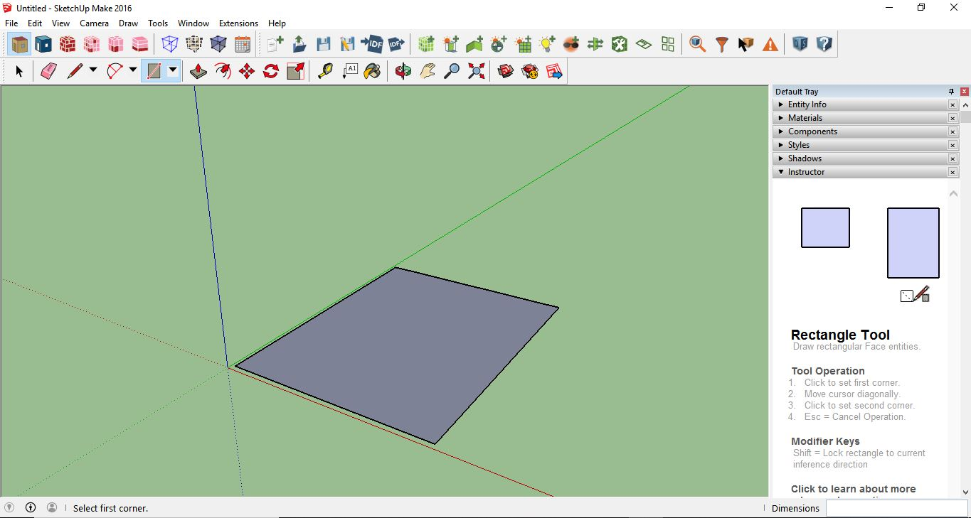

**Step 2:** offset 10 towards the center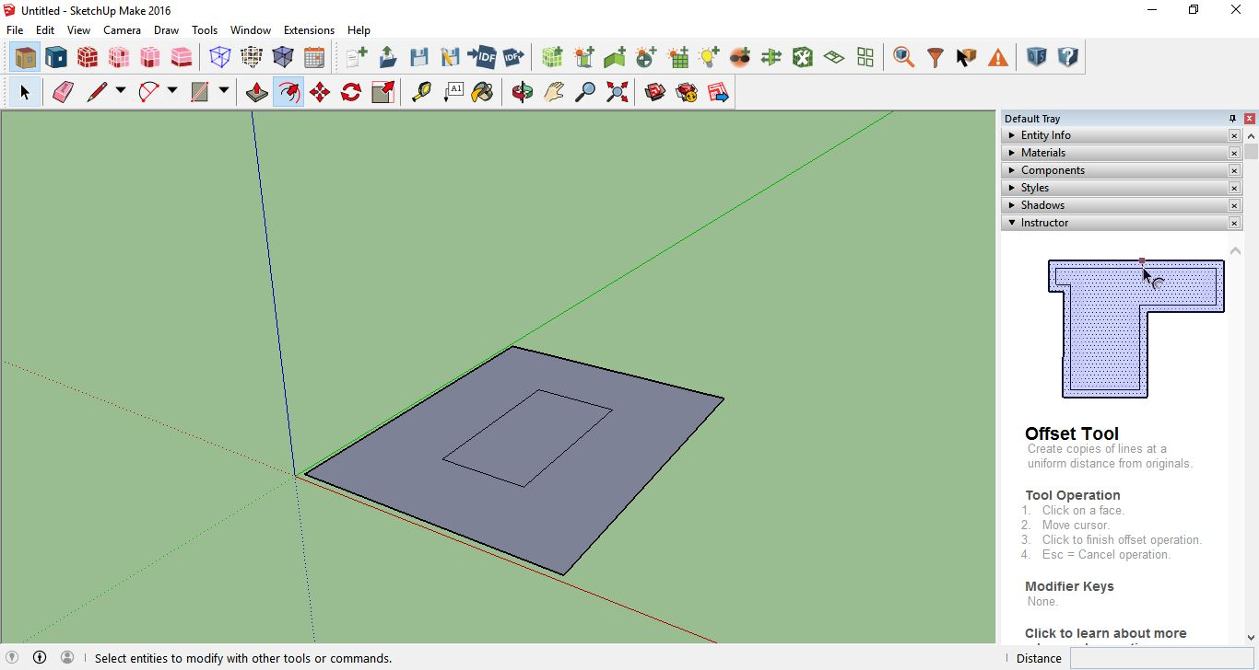

**Step 3:** connect the corners to the inner rectangle

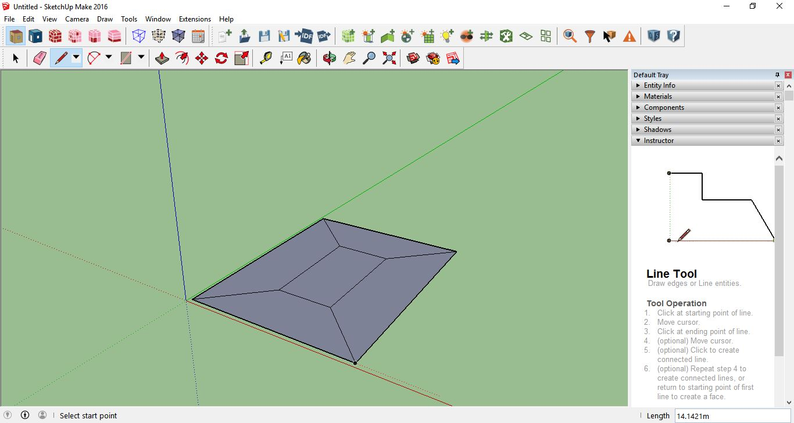

**Step 4:** click on “create spaces from diagrams” and assign 3 to the number of floors.

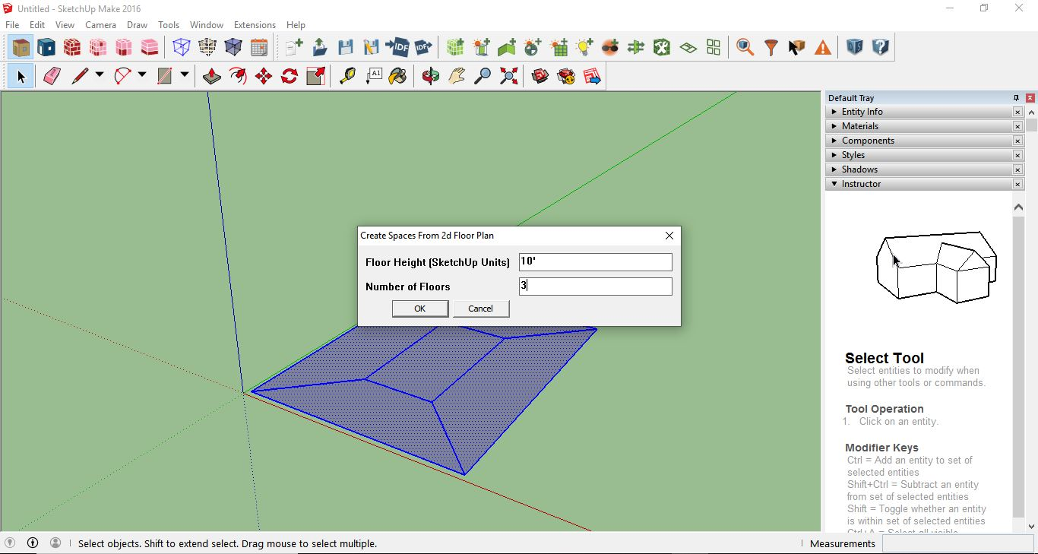

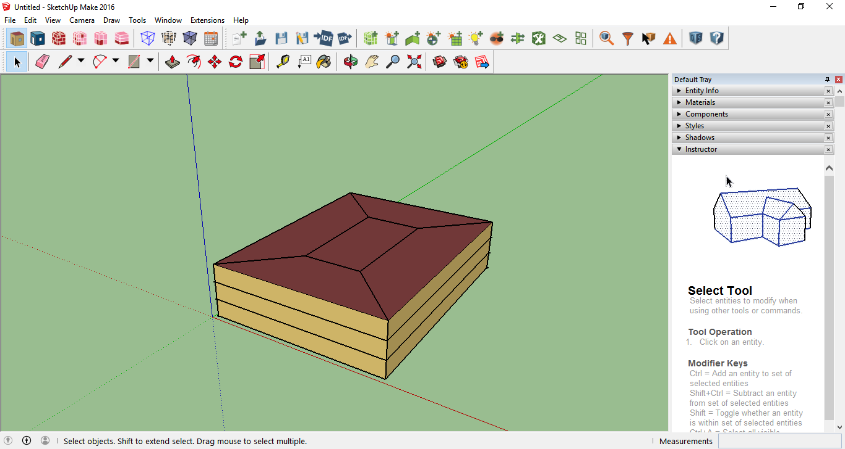

**Step 5:** click on “surface matching” and press “match in entire model”

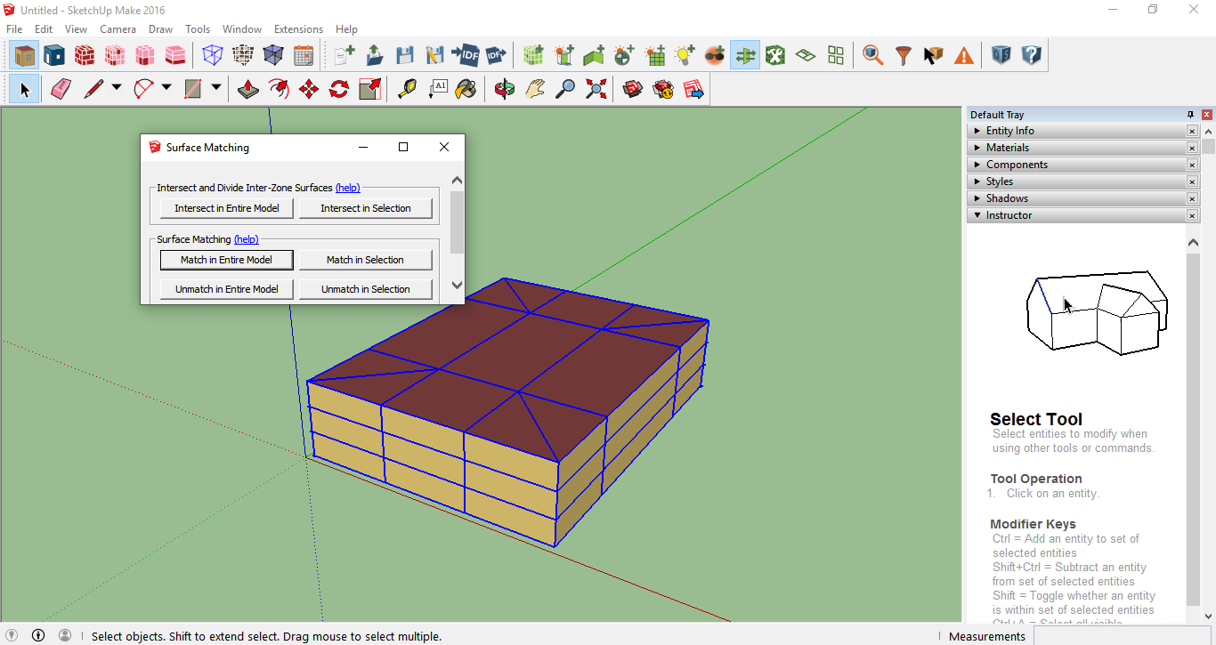

**Step 6:** go to extensions – openstudio user scripts – alter or add model elements – set window to wall ration

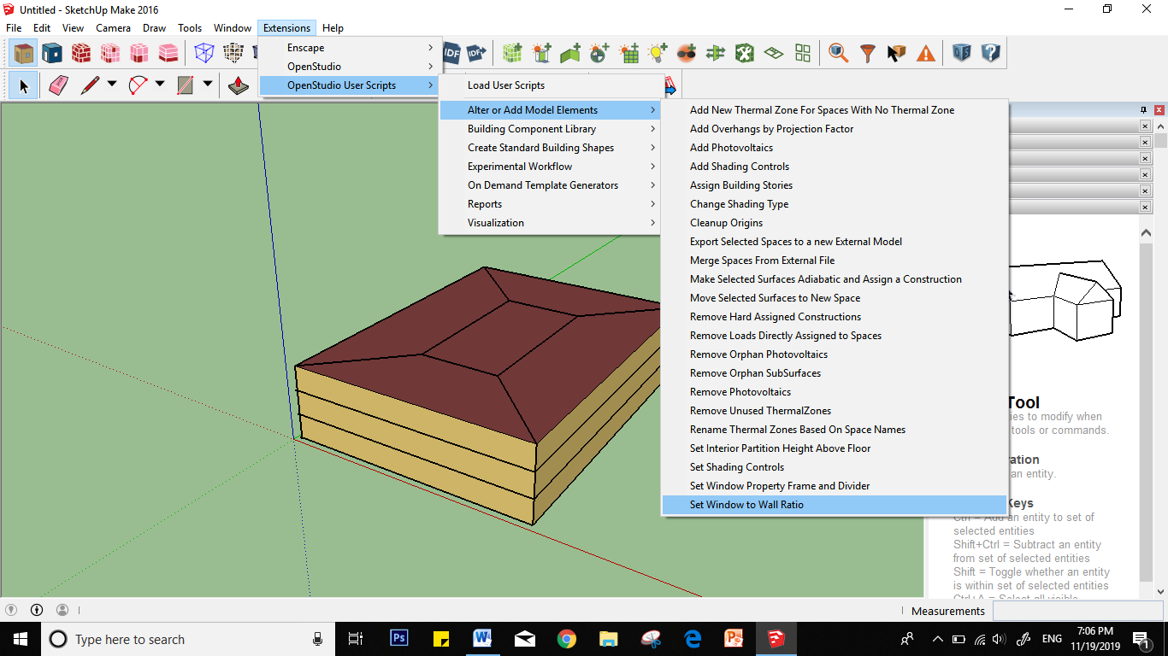

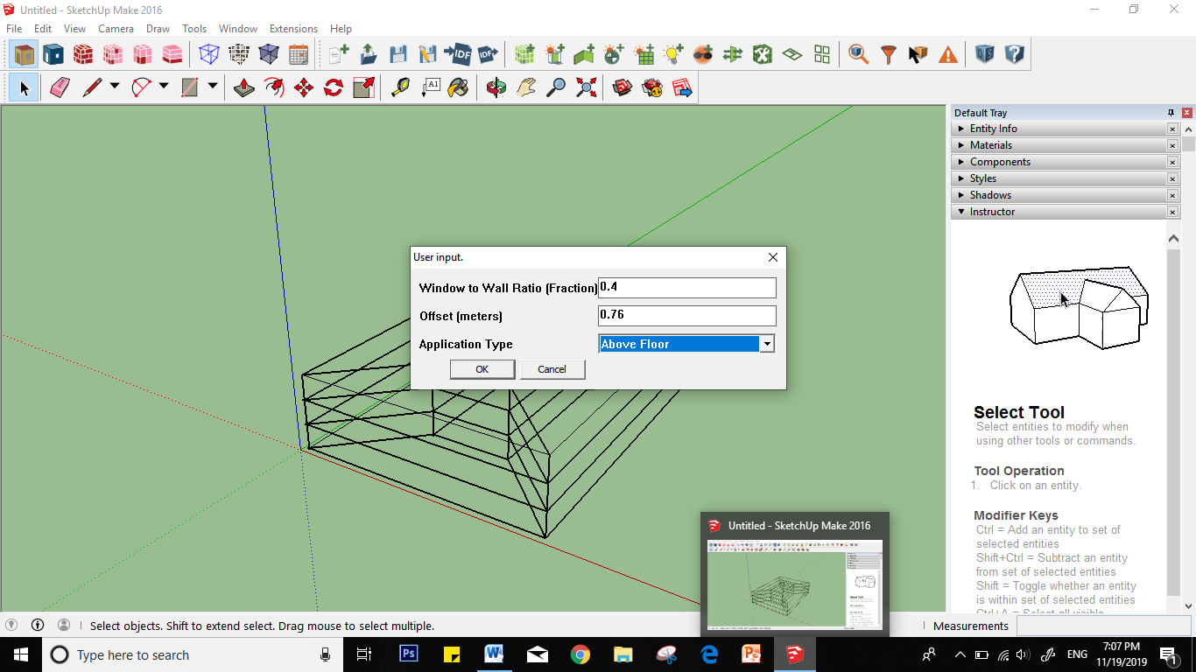

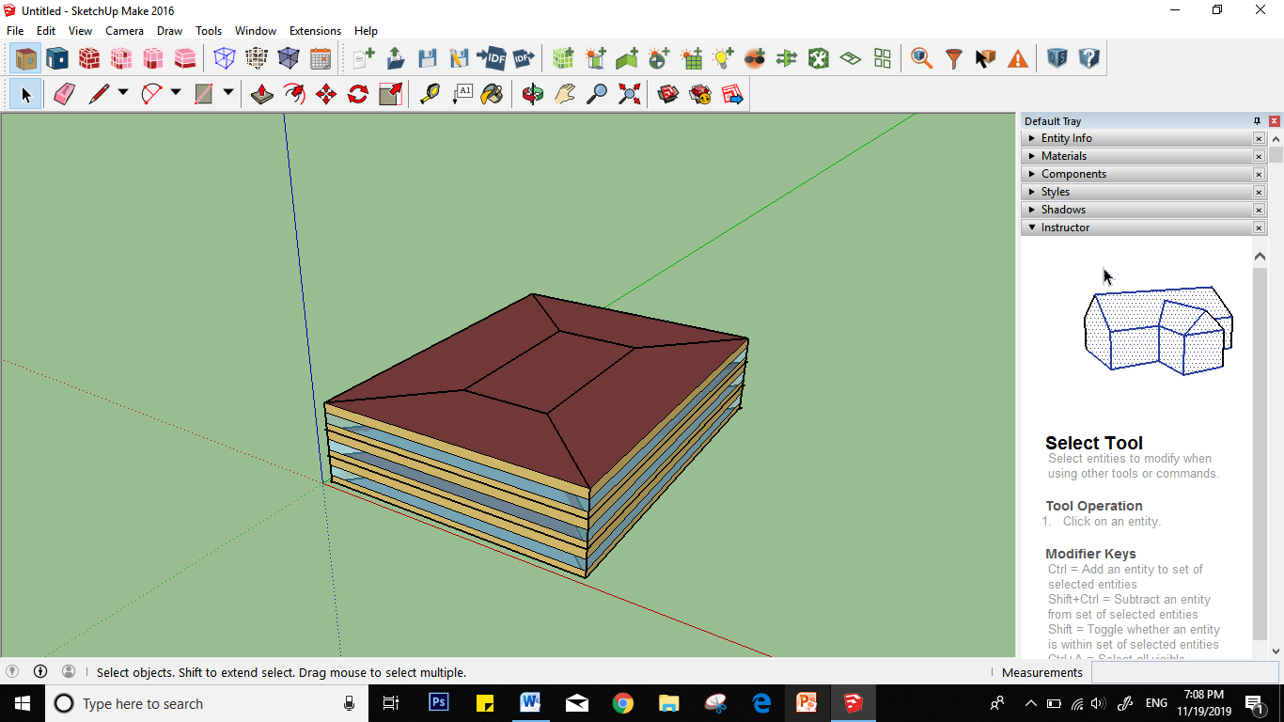

**Step 7:** press “search surfaces” and assign 90 to 360 in the surface orientation then click on search entire model

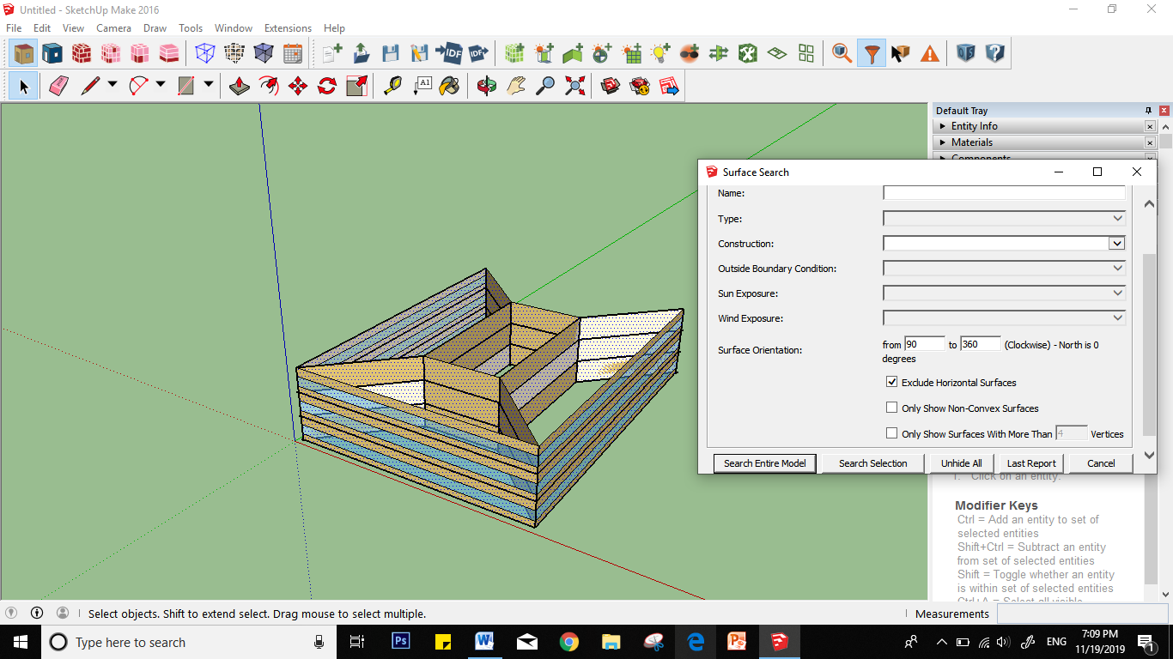

**Step 8:** go to extensions – openstudio user scripts – alter or add model elements – add overhangs by projection factor and press “ok” then save the file

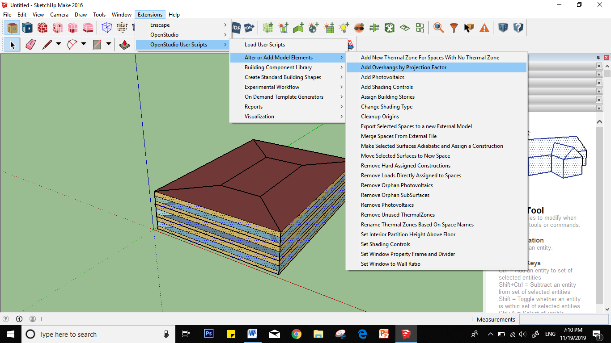

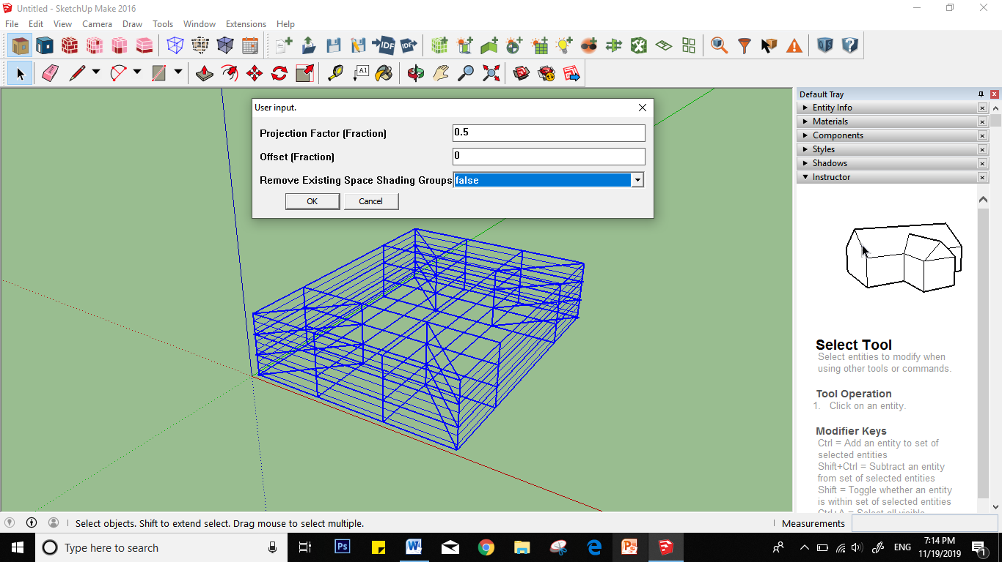

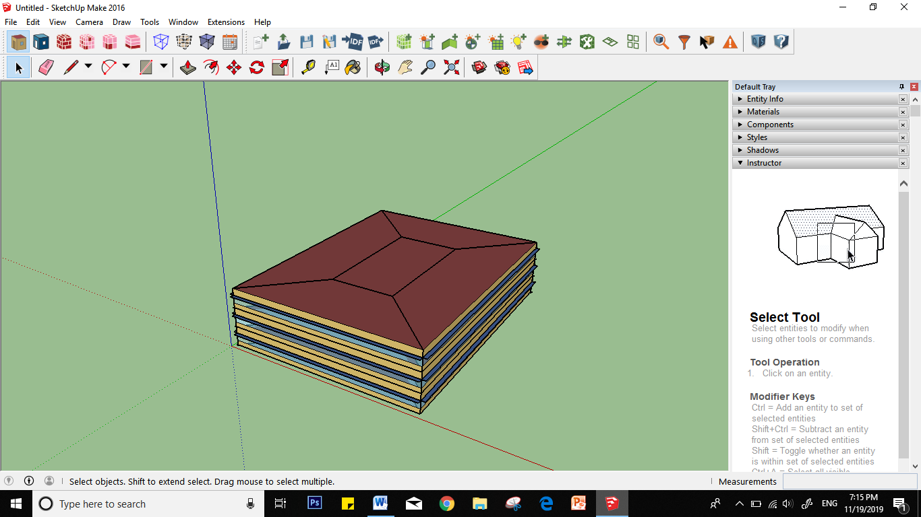

**Step 9:** select items 101 to 105 the go to “set attributes for selected spaces” and change the parameters as shown below then press “ok”

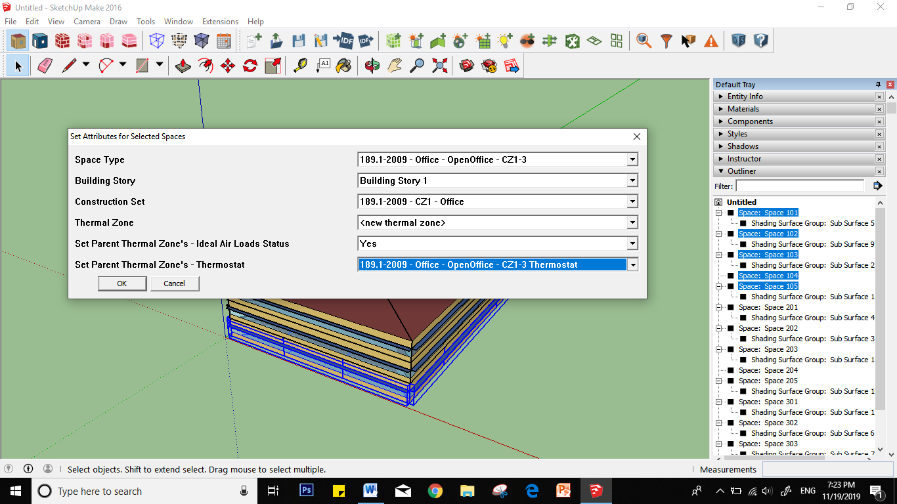

**Step 10:** repeat the same procedure from 201 to 205

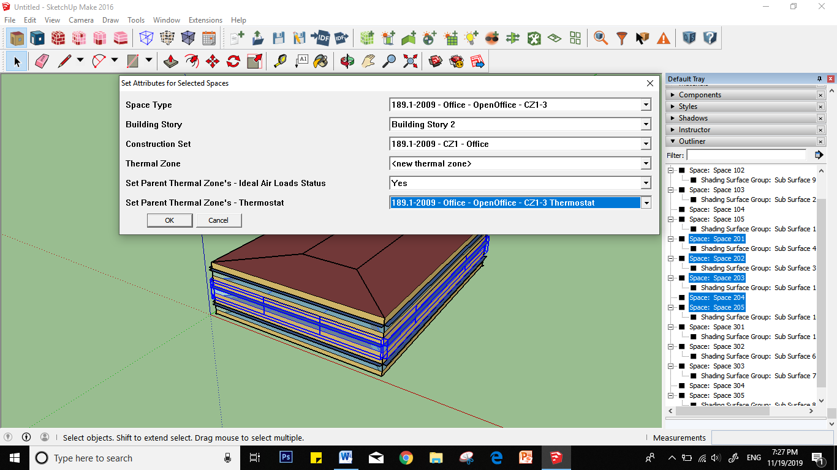

**Step 11:** repeat the same procedure from 301 to 305

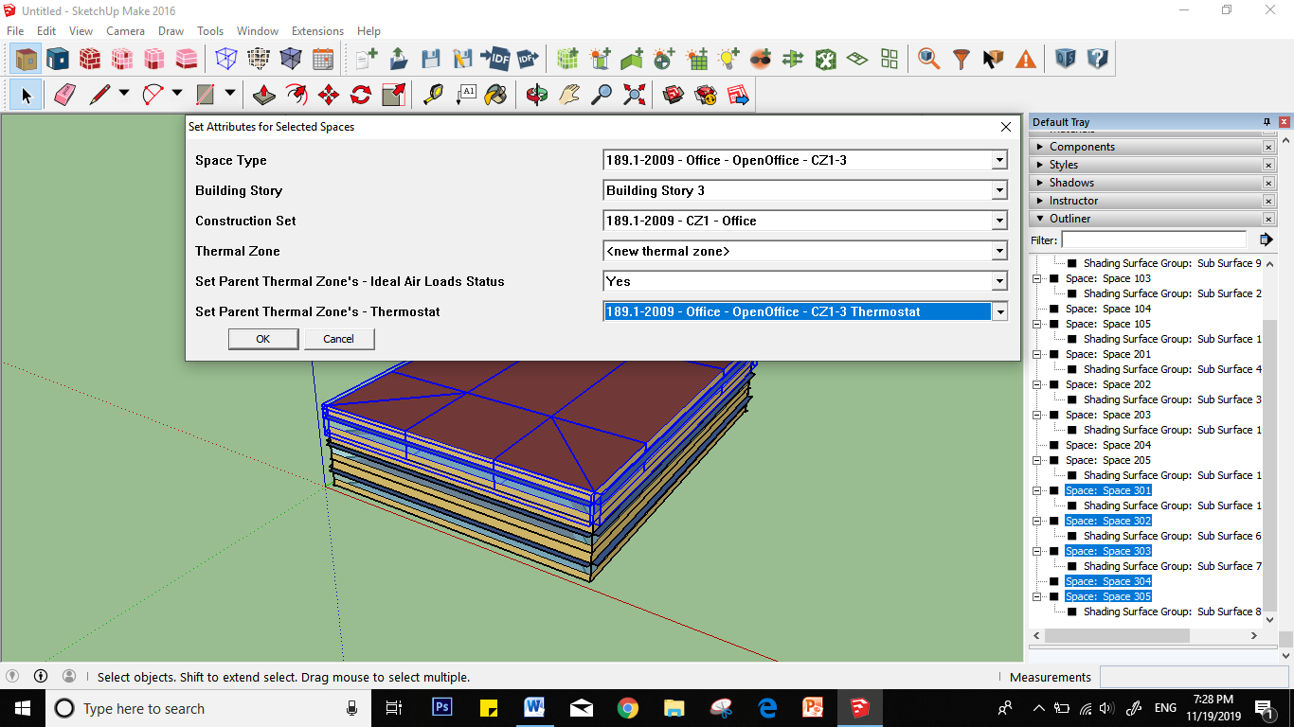

**Step 12:** launch openstudio and change the weather data to Piacenza.

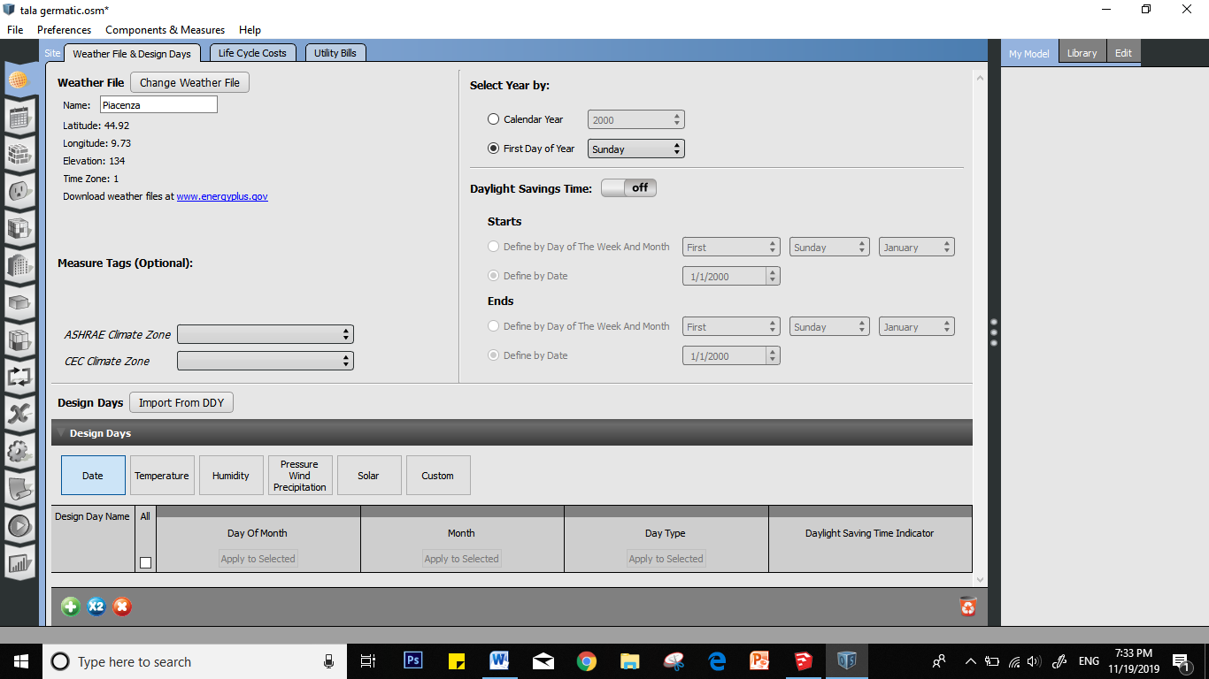

Step 13: go to “run simulation” and click run.

